**WEEK - 8**

**Name-** Aditya Mishra

**Registration Number-** RA2111003011817

**Section-** M2

**4.** Closure

A Closure is a function object that remembers values in enclosing scopes even if they are not present in memory. We have a closure in Python when a nested function references a value in its enclosing scope.

def multiplier_of(n):

def multiplier(number):

return number*n

return multiplier

**Code-**

def multiplier_of(n):  
 def multiplier(number):  
 return number*n  
 return multiplier  
closure = multiplier_of(5)  
print(closure(3))

**Output-**

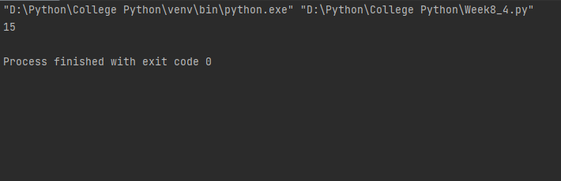

**6.** Map

A secret message needs to be sent. Use the map function to encrypt the message using Caesar cipher.

**Code-**

def caesar_cipher_encrypt(message, shift):  
 message = message.upper()  
  
 def shift_char(char):  
 if char.isalpha():  
 code = ord(char) - ord('A')  
  
 shifted_code = (code + shift) % 26  
  
 return chr(shifted_code + ord('A'))  
 else:  
 return char  
  
 encrypted_message = ''.join(map(shift_char, message))  
  
 return encrypted_message  
  
message = "SECRET MESSAGE"  
shift = 3  
encrypted_message = caesar_cipher_encrypt(message, shift)  
print(encrypted_message)

**Output-**

